2017 BenQ International Sculpture Workshop
Application Forms

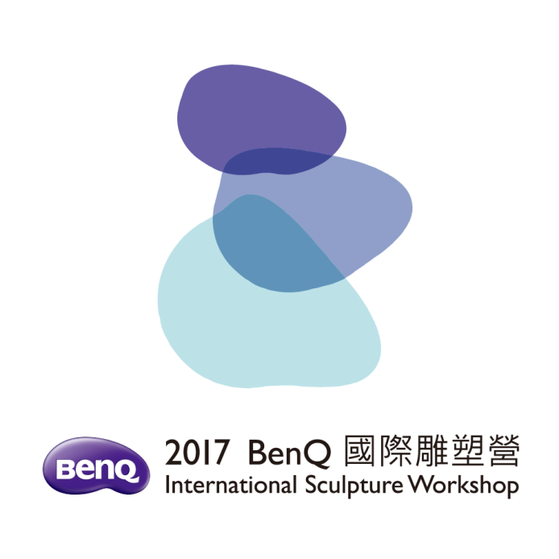

Title: 2017 BenQ International Sculpture Workshop

Curator: Chiu, Tai Yang

Organizer: BenQ Foundation

Co-Organizer: Hanho Art Co.

Personal Profile

※No. | (※Organization Use Only)
Name |  | Gender |  |  | Personal Photo
Date of Birth  YYYY/MM/DD | / /
E-mail
Nationality
Website
TEL. | (O) | (H)
FAX |  | Mobile
Contact Add.
Education Background
Sculpture Experience (include major experiences, exhibitions, awards, prizes).
Please provide a list of 5 items or less. The organizers reserve the right to edit this information in all published materials.

※No. | (※Organization Use Only)
Work Title
Dimensions（cm） | L / W / H
Materials
Work introduction: (in 300 words or less)
Model photos or design draft of the entry
（Please provide front view 150-300dpi / 800-1200 pixel）
※No. | (※Organization Use Only)
Model photos or design draft of the entry (Please provide other angles views)
Side view (Left) |  | Side view (Right)
Rear view |  | A vertical view (or other angles view)

Information of 3 previous works A
※No. (Organization Use Only)：
Name of artist：  Work Title：  Year：  Size：  Weight：  Material：  Site：  Award History：  Creation Philosophy： | Frontal View (3x5 inches)
 | Side View(3×5 inches)
 | Rear View (3×5 inches)

Information of 3 previous works B
※No. (Organization Use Only)：
Name of artist：  Work Title：  Year：  Size：  Weight：  Material：  Site：  Award History：  Creation Philosophy： | Frontal View (3x5 inches)
 | Side View(3×5 inches)
 | Rear View (3×5 inches)

Information of 3 previous works C
※No. (Organization Use Only)：
Name of artist  Work Title：  Year：  Size：  Weight：  Material：  Site：  Award History：  Creation Philosophy： | Frontal View (3x5 inches)
 | Side View(3×5 inches)
 | Rear View (3×5 inches)

Declaration for Sculpture Work
※No. | (※Organization Use Only)
Work Title
Dimensions (cm) |  | Materials
To the BenQ Foundation:

- Signer agrees to abide by the terms described in the “2017 BenQ International Sculpture Workshop Entry Prospectus”, further guarantees that the competition entry is the original design of Signer, without any plagiarism or tort, and that the information provided on the document is true and correct. If there are any errors or omissions, Signer agrees to assume all legal responsibility. In addition, Signer will follow the result of this workshop’s reviewing committee.
- Signer agrees that : the ownership and intellectual property rights (IPR) of the completed sculpture works(includes the model) are belonged to the BenQ Foundation who will possess the rights to use the image and publication of such works, including the rights to make research, photograph and duplication, as well as the rights to authorize the development in product, publication, publicity, promotion and the right to plan the location of the sculpture, and Signer shall not have any objection with the above conditions. However, creators will also possess the moral right of their sculptures. BenQ Foundation will label Signer’s name on their works.
- For publication, publicity, promotion of works, Signer agrees and acknowledges that the BenQ Foundation may use the information and material which Signer provide with the video, daily life photo, work, album and background introduction, etc., VCR and DM of Signer, and the report materials for the mass media and reporters, and such information or material will be reserved by the BenQ Foundation.

Sincerely yours,
Name of Signer：
Signature： _____________________________________________
ID/Passport Number：
Address：
Telephone：
Email Address:
Date：

